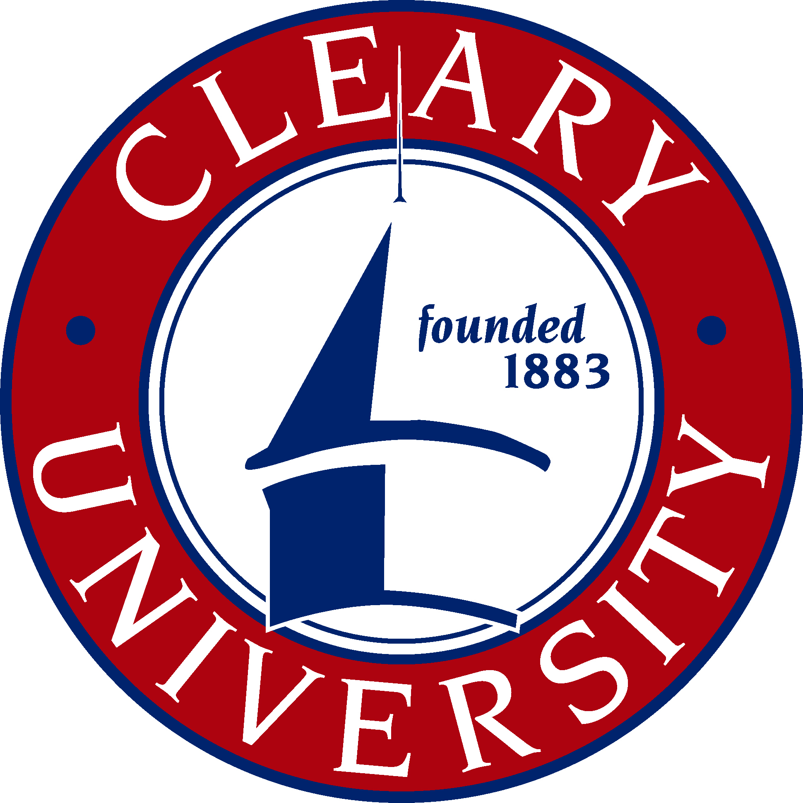
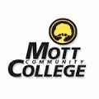

2016-17 Transfer Guide
Cleary University and Mott Community College

ABA in Business

PROGRAM REQUIREMENTS (for all concentrations)
Cleary University |  |  |  | Mott Community College
Business Core Courses
COURSE NAME |  | CREDITS |  | COURSE NAME |  | CREDIT
BAC 1000 | Foundations in Undergraduate Studies | 1
ACC 2411 | Principles of Accounting I | 4 |  | ACCT 201 | Principles of Accounting I |  | 5
BAC 1010 | Academic Communication, Technology, and Success Essentials | 3
CAS 1500 | Microsoft Office Applications | 3 |  | BUSN 180 or  COMG 154 | Microsoft Excel or  Intermediate Practical Computer Skills |  | 2 or  3
ECO 2500 | Macroeconomics | 3 |  | ECON 221 | Principles of Economics  (Macroeconomics) |  | 4
ENG 1600 | Business Composition  (Prereq: ENG 1010) | 3 |  | ENGL 101 | English Composition I |  | 3
FIN 2000 | Introduction to Business Finance  (Prereq: CAS 1500) | 3
MGT 1500 | Introduction to Business | 3 |  | BUSN 104 | Introduction to Business |  | 3
MGT 1600 | Introduction to Management | 3 |  | MGMT 181 | Principles of Management |  | 3
MKT 1500 | Enterprise Marketing | 3 |  | BUSN 255 | Principles of Marketing |  | 3
MTH 1800 | Introduction to Business Statistics  (Prereq: CAS 1500 and MTH 1700) | 3 |  | MATH 150 | Probability and Statistics |  | 4

AVAILABLE CONCENTRATIONS
ACCOUNTING/FINANCE  COURSE NAME (Four Required Courses) |  | CREDITS |  |  | COURSE NAME
ACC 2412 | Principles of Accounting II  (Prereq. ACC 2411) | 4 |  | ACCT 202 | Principles of Accounting II | 5
ACC 2520 | QuickBooks | 2 |  | ACCT 105 | Computerized Accounting | 2
ACC 2550 | Introduction to Taxation  (Prereq. ACC 2411) | 3 |  | ACCT 230 | Corporate Income Tax Accounting | 5
ACC 2801 | Intermediate Accounting I  (Prereq. ACC 2412) | 4 |  | ACCT 213 | Intermediate Accounting | 5

MARKETING/COMMUNICATION  COURSE NAME (Select Four Courses) |  |  | CREDITS |  |  | COURSE NAME | CREDIT
COM 1000 |  | Introduction to Communication Theory | 3 |  | COMM 200 | Survey of Human Communication Studies | 3
COM 2400 |  | Speech and Presentation  Techniques | 3 |  | COMM 131 | Fundamentals of Public Speaking | 3
COM 2500 |  | Multimedia Writing | 3
COM 2510 |  | Multimedia Design | 3 |  | ART 245 | Publication Design for Web I | 3
ENG 1700 |  | Business Writing | 3 |  | BUSN 206 | Business Communications | 3
HUM 2180 |  | Cross Cultural Communication | 3 |  | INTL 150 | Cross Cultural Business Issues | 3
MKT 2000 |  | Digital Marketing  (Prereq. MKT 1500) | 3
GENERAL STUDIES  COURSE NAME (Select Four Courses) |  |  | CREDITS |  |  | COURSE NAME | CREDIT
CAR 2000 | Business Career Planning |  | 2
FIN 1750 | Personal Finance |  | 3 |  | ECON 125 | Personal Money Management | 4
HLW 1000 | Health and Wellness |  | 3
HUM 1500 | Art History |  | 3 |  | ART 110  ART 111 or  112 or  116 or  214 or  215 | Art Appreciation  Art History Survey Prehistoric to 14 C. or  Art History Survey Renaissance to Modern or  Art History Survey Non Western Art or  Art History to 19 C. Art or  Art History – 20th C. Art | 3  4  4  4  4  4
PSY 1100 | Introduction to Psychology |  | 3 |  | PSYC 281 | General Psychology | 3
PSY 2100 | Abnormal Psychology |  | 3 |  | PSYC 286 | Abnormal Psychology | 3
SOC 1100 | Introduction to Sociology |  | 3 |  | SOCY 191 | Introduction to Sociology | 3
MANAGEMENT  COURSE NAME (Select Four Courses) |  |  | CREDITS |  |  | COURSE NAME | CREDIT
CAR 2000 | Business Career Planning |  | 2
HUM 2180 | Cross Cultural Communication |  | 3
MGT 2200 | Management Using Teams |  | 3
PHL 2400 | Business Ethics |  | 3 |  | PHIL 295 | Ethics | 3
PLS 1100 | Geopolitical Foundations |  | 3
PLS 2200 | Federal Government |  | 3 |  | PSCN 170 | Introduction to American Government | 3
PMG 2000 | Project Management |  | 3

Notes
Note 1: 120 semester credits are required for a Bachelor of Business Administration (BBA); 60 semester credits are required for an Associate in Business Administration (ABA).
Note 2: Electives/General Education may be any Mott Community College courses or transfer or may include credit for prior learning or proficiency exam credit. There is no fee for prior learning evaluation prior to the final term of the program.
Note 3: Scholarships are available for Mott Community College transfer students. Other scholarships and financial aid are available to all Cleary students.
Note 4: Cleary core and major courses are completed on-ground or distance learning online. Thirty credits (thirty-seven for BBA degree completion programs) must be completed with Cleary University to fulfill residency requirements. The maximum number of credits that may be transferred to Cleary University is 90 semester (83 semester for BBA degree completion degrees) credits. Consult a Cleary academic advisor for class schedule information.

