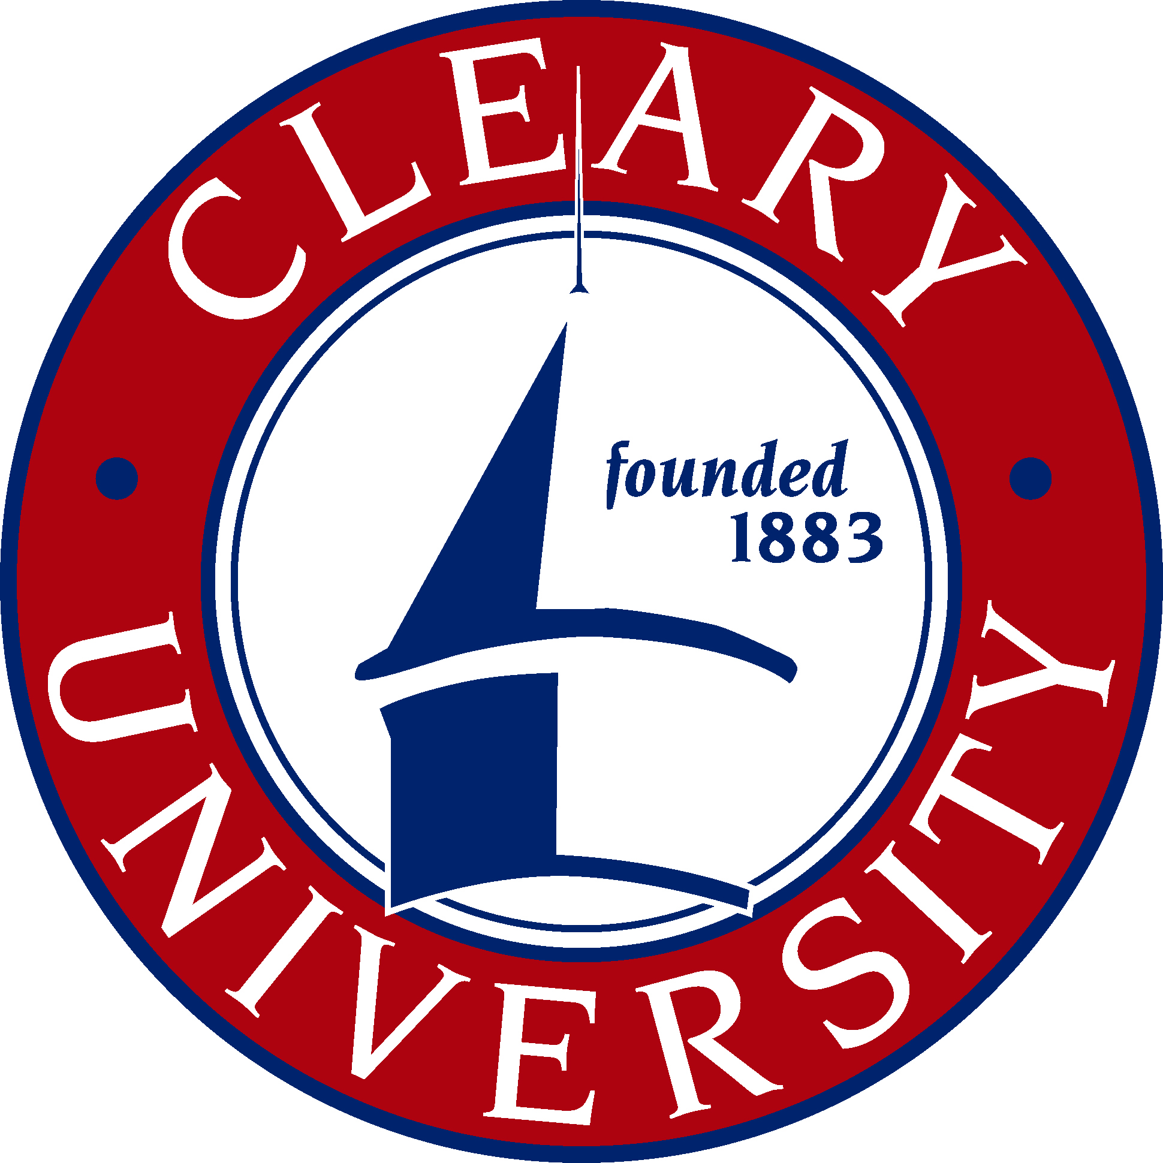
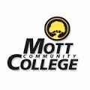

2016-17 Transfer Guide
Cleary University and Mott Community College

BBA in Executive Management

CORE SUBJECTS & PROJECT SEQUENCE
Cleary University |  |  |  | Mott Community College
Business Core Courses
COURSE NAME |  | CREDIT |  |  |  | COURSE NAME |  | CREDITS
BAC 3000 | Business Research and  Communication | 3
MTH 3440 | Quantitative Business Analysis  (Prereq: CAS 1500 and MTH 1800) | 3
ACC 4012 | Financial and Managerial Accounting  (Prereq: ACC 2411) | 3
FIN 4000 | Financial Management  (Prereq: FIN 2000 and MTH 3440) | 3
OPM 4000 | Operations Management | 3
MGT 6750 | International Business | 3
MGT 6360 | Management and Organizational Behavior | 3
MGT 3400 | Managing Projects and Processes in Organizations | 3
MKT 6050 | Strategic Marketing Management | 3
PJT 4910 | Professional Project I | 3
LAW 6050 | Law and Ethics | 3
PJT 4920 | Professional Project II | 3

LOWER DIVISION REQUIREMENT |  | CREDITS |  |  | COURSE NAME | CREDITS
BAC 1000 | Foundations in Undergraduate Studies | 1

Notes
Note 1: 120 semester credits are required for a Bachelor of Business Administration (BBA); 60 semester credits are required for an Associate in Business Administration (ABA).
Note 2: Electives/General Education may be any Mott Community College courses or transfer or may include credit for prior learning or proficiency exam credit. There is no fee for prior learning evaluation prior to the final term of the program.
Note 3: Scholarships are available for Mott Community College transfer students. Other scholarships and financial aid are available to all Cleary students.
Note 4: Cleary core and major courses are completed on-ground or distance learning online. Thirty credits (thirty-seven for BBA degree completion programs) must be completed with Cleary University to fulfill residency requirements. The maximum number of credits that may be transferred to Cleary University is 90 semester (83 semester for BBA degree completion degrees) credits. Consult a Cleary academic advisor for class schedule information.

