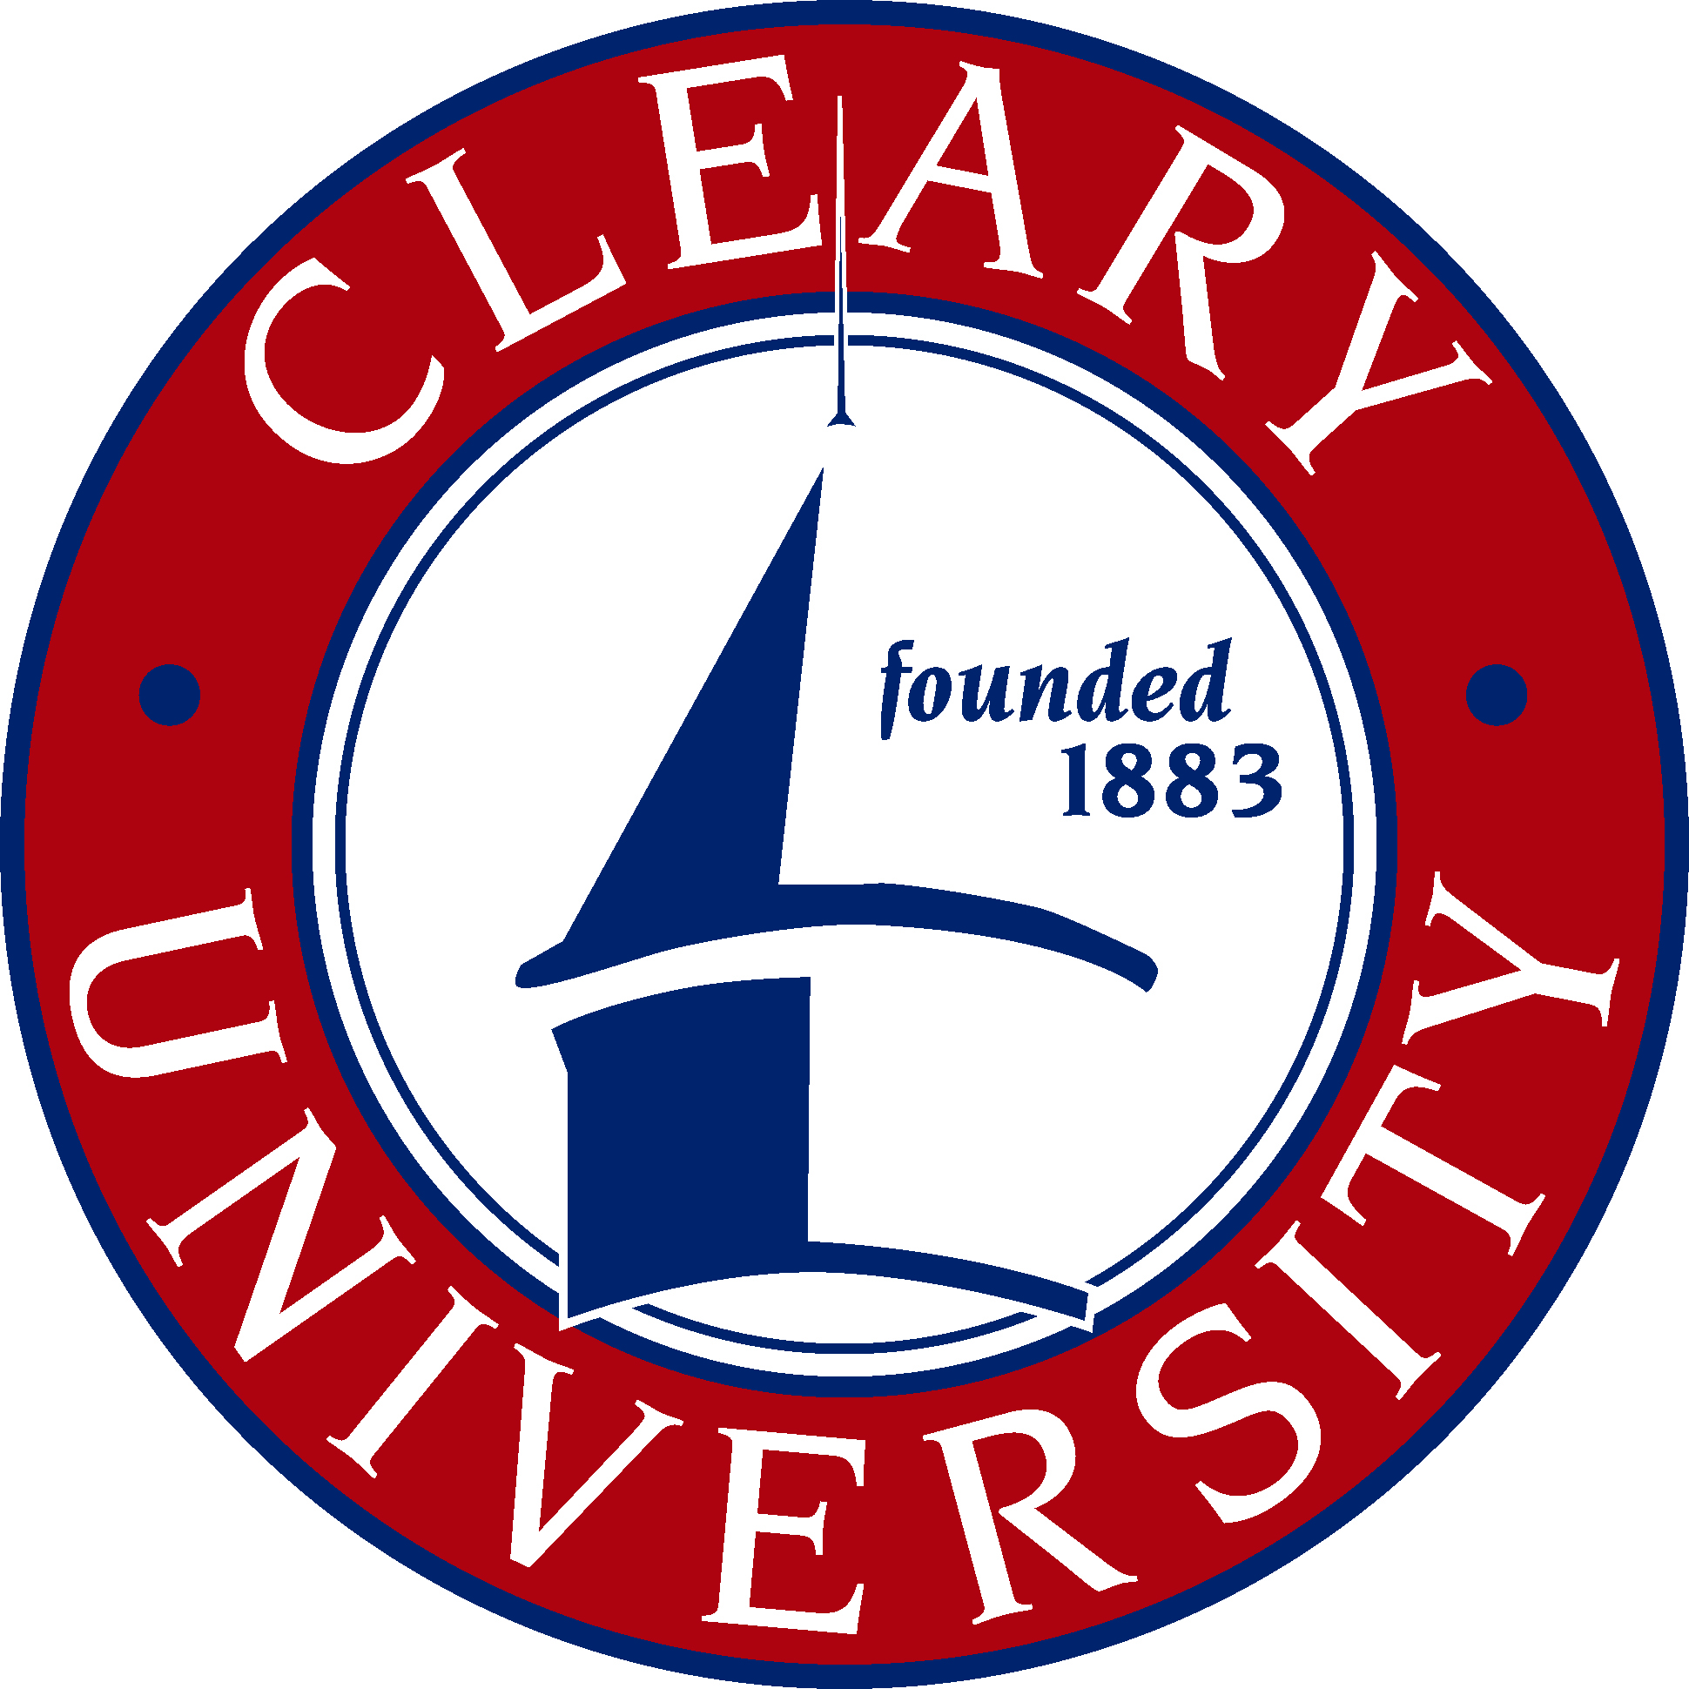

2016-17 Transfer Guide
Cleary University and Mott Community College

BBA in Intradisciplinary Business Studies

BUSINESS CORE COURSES

Cleary University |  |  |  | Mott Community College
Business Core Courses
COURSE NAME |  | CREDITS |  | COURSE NAME |  | CREDITS
BAC 3000 | Business Research and  Communication | 3

MAJOR COURSES
Approved Upper Division Course Work 24
(8 courses)
PROJECT SEQUENCE

MGT 3400 | Managing Projects and Processes in Organizations | 3
PJT 4910 | Professional Project I | 3
PJT 4920 | Professional Project II  (Prereq. PJT 4910, C or higher) | 3
LOWER DIVISION REQUIREMENT
BAC 1000 | Foundations in Undergraduate Studies | 1

Notes
Note 1: 120 semester credits are required for a Bachelor of Business Administration (BBA); 60 semester credits are required for an Associate in Business Administration (ABA).
Note 2: Electives/General Education may be any Mott Community College courses or transfer or may include credit for prior learning or proficiency exam credit. There is no fee for prior learning evaluation prior to the final term of the program.
Note 3: Scholarships are available for Mott Community College transfer students. Other scholarships and financial aid are available to all Cleary students.
Note 4: Cleary core and major courses are completed on-ground or distance learning online. Thirty credits (thirty-seven for BBA degree completion programs) must be completed with Cleary University to fulfill residency requirements. The maximum number of credits that may be transferred to Cleary University is 90 semester (83 semester for BBA degree completion degrees) credits. Consult a Cleary academic advisor for class schedule information.

